**Logic Apps**

Whenever we need to integrate multiple services inside Azure, there’s no better way to do it than Logic Apps.

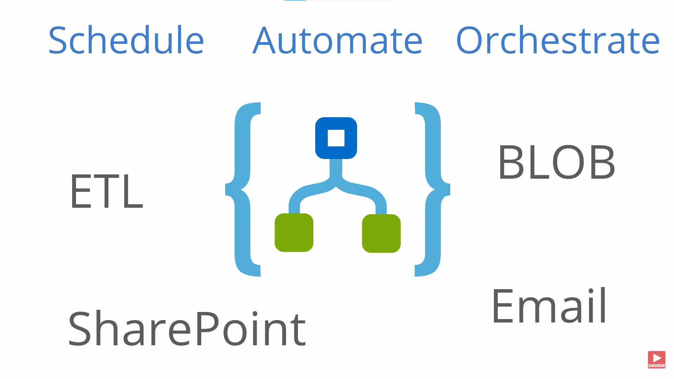

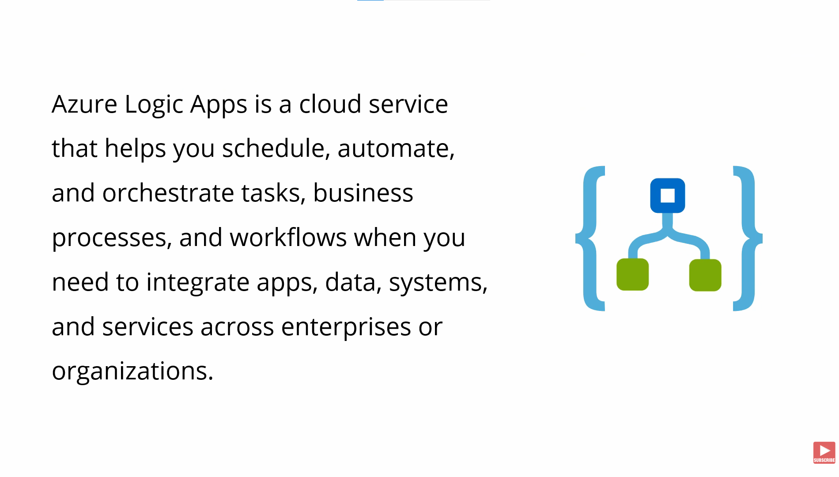

Every step of the logic app is an action. So it’s action followed by an action followed by an action.

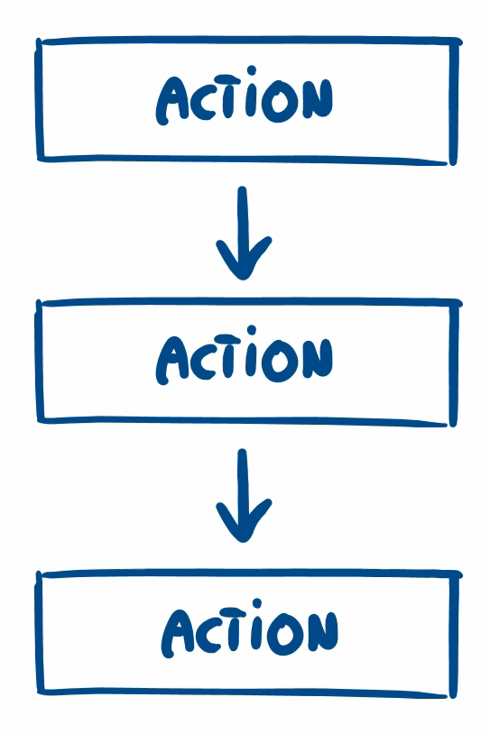

These actions can have few conditions based on which we need to proceed.

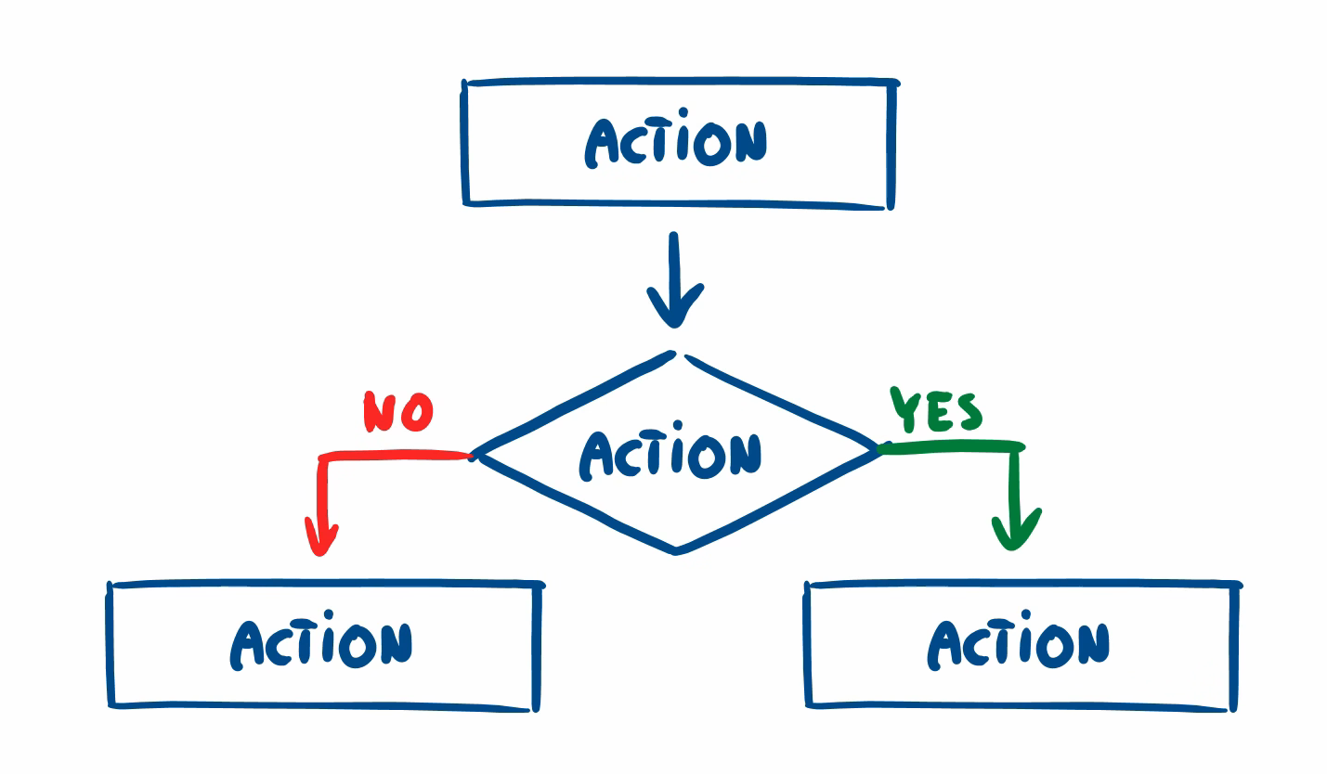

The output of one action can be used as the input to the next action. Previous action outputs can also be used as the inputs to the action.

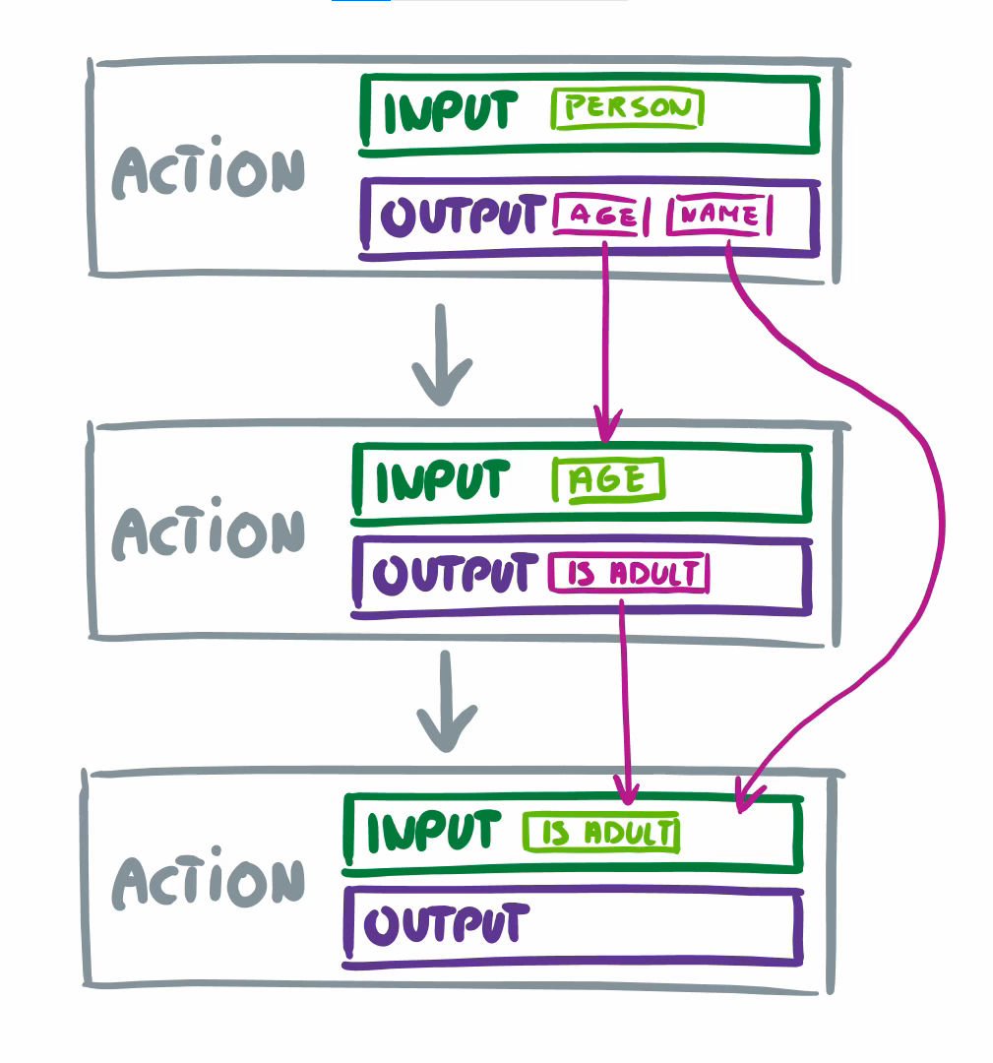

First Action will start its action based on the trigger we have configured on it. There are more than 200 connectors we can configure.

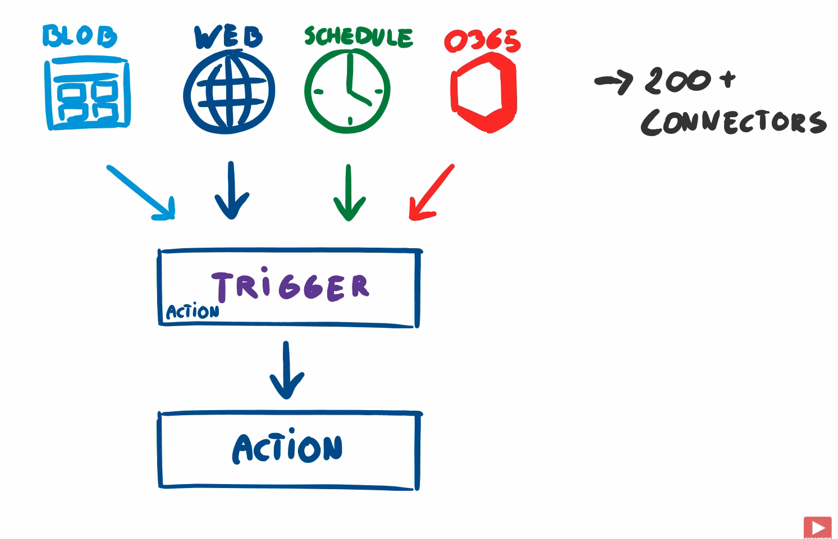

The example that we are doing first is the web request.

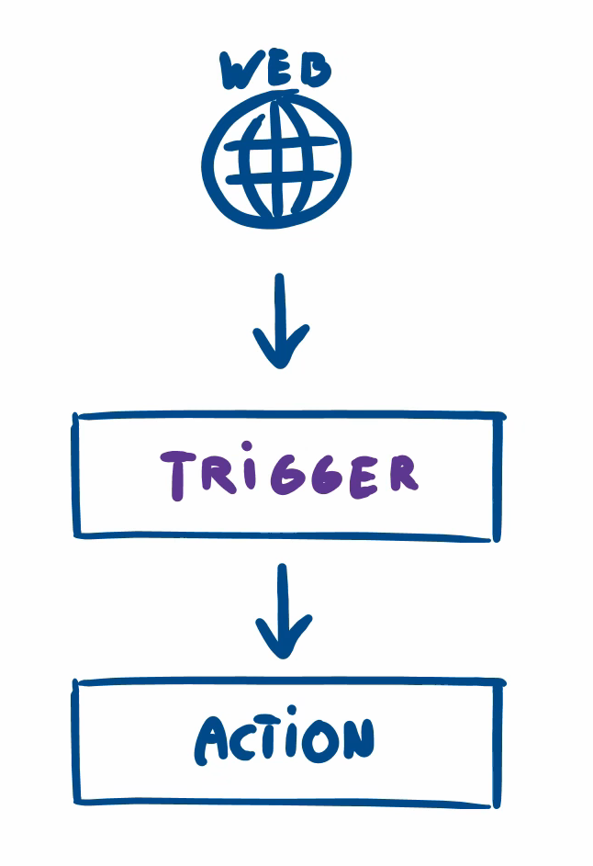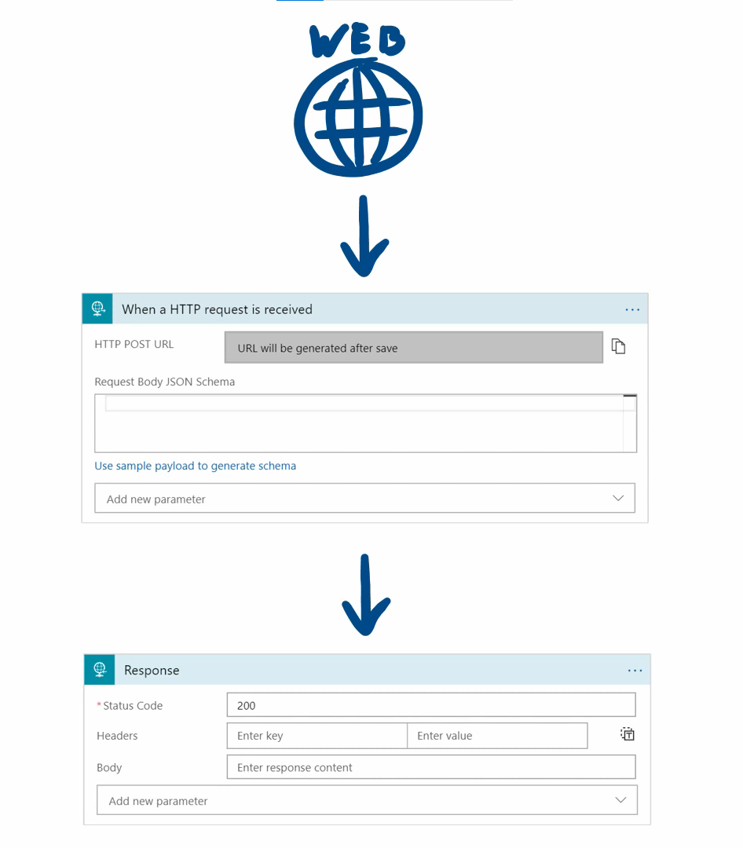



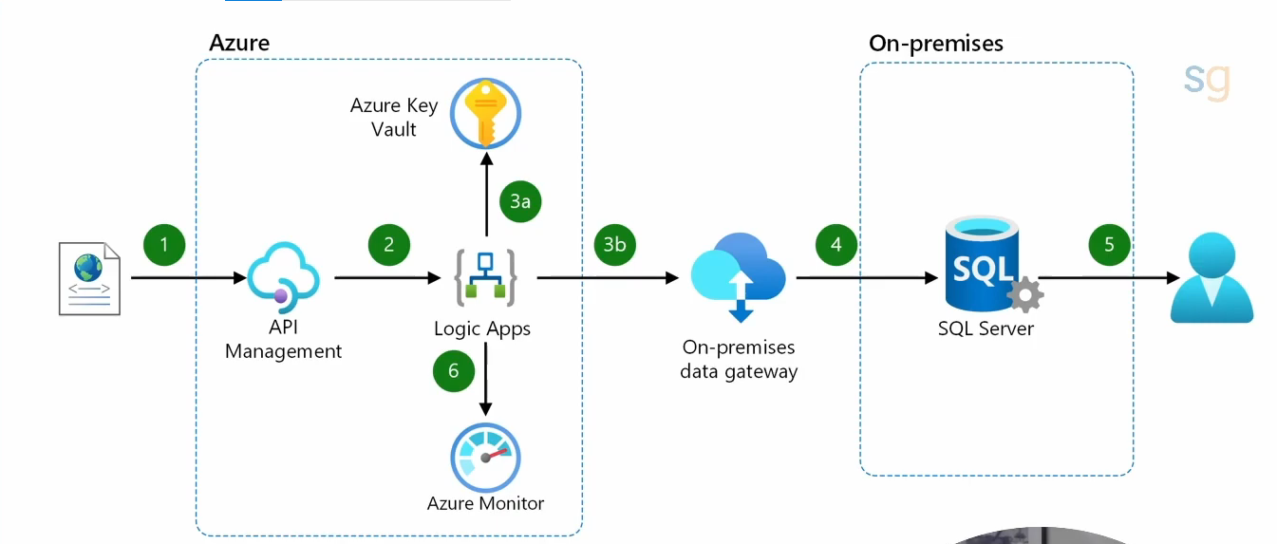

Go to the Azure portal and search for Logic Apps.

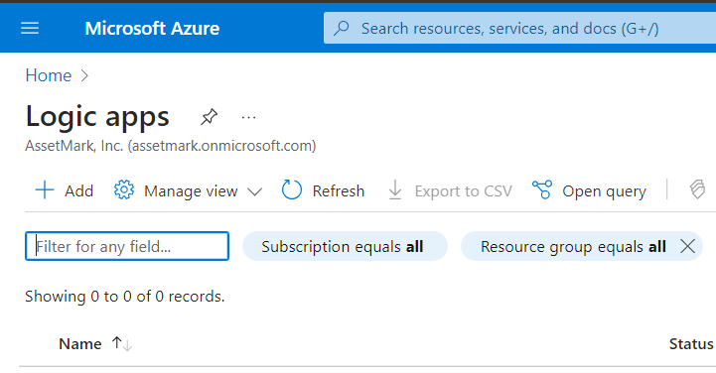

Click on add